BUSINESS PLAN

Lone Star Mobile Bikes: Austin Business Plan & SBA Loan Request

October 2026

Austin’s Underserved Mobile Bike Repair Market
Austin's cycling commuter base is growing, yet repair access remains concentrated in fixed shops with limited hours and locations distant from where people live and work. A mobile van eliminates the two biggest friction points: travel time and shop scheduling. Demand is strongest among downtown and East Austin commuters, university-adjacent riders, and offices that encourage bike commuting but lack on-site maintenance options.
The competitive void is not a lack of mechanics; it is a lack of convenient, scheduled, on-location service at a transparent price. Lone Star Mobile Bikes can occupy that gap with route-based service, employer partnerships, and a booking model built around the customer's location rather than a storefront.
Market note. Demand estimates in this plan are indicative and should be confirmed with local rider surveys and employer conversations before submission.

On-Demand Repair Services and Transparent USD Pricing
Lone Star Mobile Bikes operates a fully equipped repair van that travels to the customer's home, office, or roadside location. This model removes the barrier of transporting a bicycle to a shop, which is critical for Austin commuters who rely on their bikes for daily transport. Services are grouped into three tiers: Basic Tune-Up, Complete Service, and Flat-Rate Repair Menu. Every job receives a fixed USD quote before work begins, and no work proceeds without customer approval.
Service Tier | What Is Included | Price (USD)
Basic Tune-Up | Gear and brake adjustment, tire pressure, chain lubrication, safety check | $65
Complete Service | Basic Tune-Up plus wheel truing, drivetrain cleaning, bearing check, cable inspection | $120
Flat-Rate Repair Menu | Tube replacement ($20 plus tube), brake pad replacement ($25 plus pads), chain replacement ($30 plus chain), derailleur adjustment ($35) | From $20 plus parts
Office Fleet Plan | Monthly on-site maintenance for 5 or more employee bicycles, scheduled visit | $45 per bike per month
Emergency Call-Out | Same-day roadside repair within Austin city limits, includes first 30 minutes of labour | $95

Pricing Note. All prices are indicative estimates for the Austin market. Confirm current supplier prices for parts and local wage benchmarks before finalizing the price list or submitting a loan application.

The Basic Tune-Up at $65 is priced below the typical Austin walk-in shop rate while covering the cost of a mobile visit. The Complete Service at $120 reflects additional labor and parts inspection time. The Office Fleet Plan creates recurring monthly revenue and reduces drive time by serving multiple bicycles in one location. Emergency Call-Out pricing accounts for the premium nature of same-day roadside service. These figures are estimates and should be validated against at least three local competitors and current parts invoices before launch.

Verified Startup Cost Breakdown in USD
The following table outlines the estimated startup costs required to launch Lone Star Mobile Bikes in Austin, Texas. These figures are based on current market rates for commercial vehicles, professional-grade repair tools, and Texas-specific licensing fees. Confirm current supplier prices and insurance quotes before submission.
Category | Item Description | Estimated Cost (USD)
Vehicle | Used Cargo Van (Ford Transit or similar) + Branding Wrap | $25,000
Equipment | Professional Repair Tools, Workbench, Generator | $8,000
Inventory | Initial Stock of Tubes, Tires, Chains, Brake Pads | $5,000
Legal & Licensing | Texas LLC Formation, City of Austin Business License | $1,500
Insurance | Commercial Auto & General Liability (6 months prepay) | $3,500
Marketing | Website Development, Local SEO, Print Materials | $2,000
Working Capital | Cash Reserve for Initial Operations (3 months) | $15,000
Total | Estimated Total Startup Capital Required | $60,000
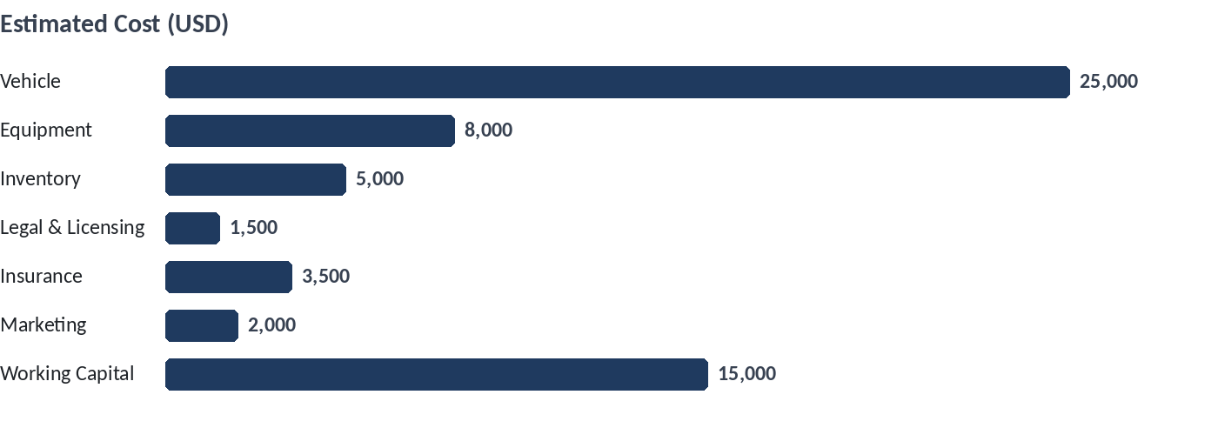
Figure 1. Estimated Cost (USD)
Note on Estimates. All figures provided are realistic estimates for the Austin market. Actual costs may vary based on vehicle condition and insurance provider selections. Verify all quotes prior to finalizing the loan request.

Conservative 12-Month Cash-Flow Projection
The table below presents a conservative 12-month cash-flow projection for Lone Star Mobile Bikes. Revenue growth is capped at 3% month-over-month to avoid over-optimistic assumptions. Startup costs are treated as month 0 outflows and do not appear in the monthly columns. All figures are estimates in USD. Confirm current supplier prices, insurance premiums, and fuel costs before submission.
Month | Revenue (USD) | Operating Expenses (USD) | Net Cash Flow (USD) | Cumulative Cash Flow (USD)
1 | 2,000 | 3,200 | -1,200 | -1,200
2 | 2,060 | 3,200 | -1,140 | -2,340
3 | 2,122 | 3,200 | -1,078 | -3,418
4 | 2,186 | 3,200 | -1,014 | -4,432
5 | 2,252 | 3,200 | -948 | -5,380
6 | 2,320 | 3,200 | -880 | -6,260
7 | 2,390 | 3,200 | -810 | -7,070
8 | 2,462 | 3,200 | -738 | -7,808
9 | 2,536 | 3,200 | -664 | -8,472
10 | 2,612 | 3,200 | -588 | -9,060
11 | 2,690 | 3,200 | -510 | -9,570
12 | 2,771 | 3,200 | -429 | -9,999
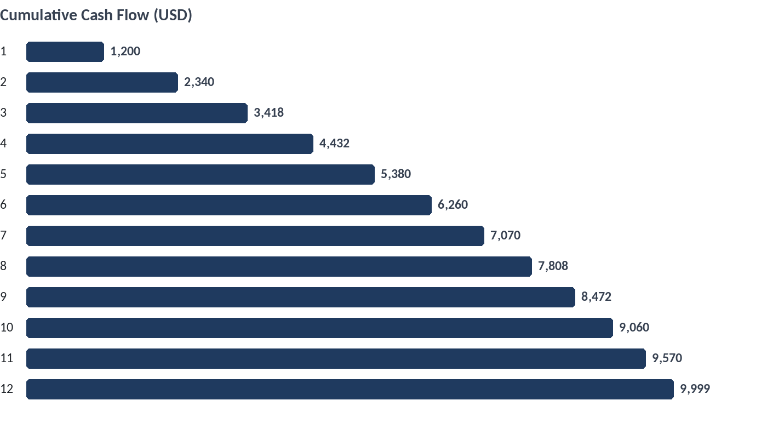
Figure 2. Cumulative Cash Flow (USD)
The projection shows a cumulative cash deficit of approximately $9,999 by the end of month 12. The working capital portion of the SBA loan request covers this deficit. Under these conservative assumptions, the business does not reach monthly break-even within the first year. The inflection point toward sustainability is projected to occur in months 18 to 24, assuming continued 3% monthly revenue growth and stable operating expenses. Confirm current supplier prices, insurance premiums, and fuel costs before submission.
Estimate Notice. All figures in this section are estimates. Confirm current supplier prices, insurance premiums, and fuel costs before submission.

Targeted Outreach to Austin Commuters and Corporate Offices
Lone Star Mobile Bikes will prioritize direct engagement with Austin’s growing commuter population. Marketing efforts will focus on high-traffic cycling corridors such as the Lady Bird Lake Trail and the Lance Armstrong Bikeway. Branded signage will be deployed at key trailheads, and partnerships with local coffee shops near major employment hubs will offer discount codes for first-time repairs. This hyper-local approach minimizes ad spend while maximizing visibility among target users who value convenience and speed.
Corporate outreach will target mid-to-large tech firms in North Austin and the Domain area. We propose offering on-site 'Bike Health Check' days where employees receive free minor adjustments and discounted major repairs. These events serve as lead generation tools, allowing us to capture contact information for future mobile service requests. By positioning the van as a workplace perk, we reduce customer acquisition costs and build recurring revenue streams through office-based contracts.
Marketing Budget Constraint. All marketing activities are designed to operate within a lean budget. Confirm current local permit fees for trailhead signage with the City of Austin Parks and Recreation Department before printing materials.

Mobile Operations, Texas Licensing, and Liability Coverage
Lone Star Mobile Bikes will operate a single mobile repair van serving Austin, Texas. The vehicle will be a used cargo van upfitted with a workbench, tool storage, and a generator. Operations will follow a scheduled route model: mornings in central business districts, afternoons in residential clusters, and on-site service for corporate accounts. All repairs will be performed at the customer's location.
The business will comply with Texas Department of Motor Vehicles (TxDMV) registration and inspection requirements for commercial vehicles. It will obtain a City of Austin business registration and a Texas Sales and Use Tax Permit. Coverage will include commercial auto insurance, general liability insurance, and garage keepers liability. Minimum recommended limits are $1,000,000 per occurrence for general liability and $1,000,000 for commercial auto. Workers' compensation insurance will be added when the first employee is hired.
Confirm Before Submission. All figures in this section are estimates. Confirm current fees and insurance premiums with the Texas Comptroller, City of Austin, and a licensed insurance agent before submission.

Operational, Regulatory, and Market Risk Assessment
Austin’s climate presents a dual-edged sword for mobile bicycle repair. While mild winters allow for year-round operations, intense summer heat from June through August often suppresses commuter cycling volumes, leading to a seasonal dip in demand. To mitigate this revenue volatility, Lone Star Mobile Bikes will pivot marketing efforts during peak heat months toward indoor corporate clients and offer evening appointment slots when temperatures are lower. Additionally, the business will maintain a cash reserve equivalent to three months of operating expenses to buffer against these predictable seasonal fluctuations.
Operating a mobile service vehicle in Austin requires navigating specific municipal regulations, including commercial vehicle parking restrictions and potential permitting delays for street-side service zones. Changes in City of Austin ordinances regarding commercial activity on public rights-of-way could impact operational flexibility. To address this, the business will prioritize partnerships with private office complexes and residential HOAs that provide dedicated, permitted parking spaces for service vans. This strategy reduces reliance on public street parking and minimizes exposure to regulatory shifts or enforcement actions.
Insurance and Liability Considerations. Texas law mandates specific minimum liability coverage for commercial vehicles, but standard policies may not fully cover tools and parts stored in the van. Lone Star Mobile Bikes will secure a comprehensive commercial auto policy with inland marine coverage for equipment. Regular reviews of policy limits will be conducted annually to ensure alignment with the growing value of inventory and tools. Confirm current supplier prices and insurance premiums before finalizing the budget.

The barrier to entry for mobile bike repair is relatively low, posing a risk of increased local competition. However, Lone Star Mobile Bikes differentiates itself through specialized corporate contracts and rapid response times guaranteed by its localized routing algorithm. To mitigate the risk of price wars, the business will focus on value-added services such as fleet maintenance for bike-share programs and corporate wellness initiatives, which are less sensitive to price competition than individual consumer repairs. Continuous monitoring of competitor pricing and service offerings will inform dynamic adjustments to the service menu.

SBA 7(a) Loan Request: $85,000 Use of Proceeds and Repayment Plan
Lone Star Mobile Bikes requests an $85,000 SBA 7(a) loan to launch a mobile bicycle repair van serving Austin, Texas. The proceeds cover a used cargo van and upfit, tools and parts inventory, Texas licensing and commercial insurance, working capital, and loan fees. Repayment is modeled over a 10-year term at a fixed 8.5% annual rate, with monthly payments of approximately $1,054. The business projects positive monthly net cash flow by month 7 and full repayment from operating cash flow without a balloon payment. All figures are estimates; confirm current supplier prices, insurance quotes, and SBA fees before submission.
Use of Proceeds | Amount (USD) | Notes
Used cargo van (2019-2021, <80k miles) | 28,000 | Estimate; confirm current Austin market prices
Van upfit: shelving, workbench, power, lighting | 9,500 | Estimate; confirm with upfitter
Professional tools and diagnostic equipment | 7,500 | Estimate; confirm supplier quotes
Initial parts and consumables inventory | 6,000 | Estimate; confirm distributor pricing
Texas licensing, registration, and permits | 1,200 | Estimate; confirm TX DMV and City of Austin fees
Commercial auto and general liability insurance (12 months) | 4,800 | Estimate; confirm broker quotes
Working capital (6 months operating reserve) | 24,000 | Estimate; confirm payroll and fuel costs
SBA guarantee fee and closing costs | 4,000 | Estimate; confirm current SBA fee schedule
Total | 85,000 | Sum of above estimates
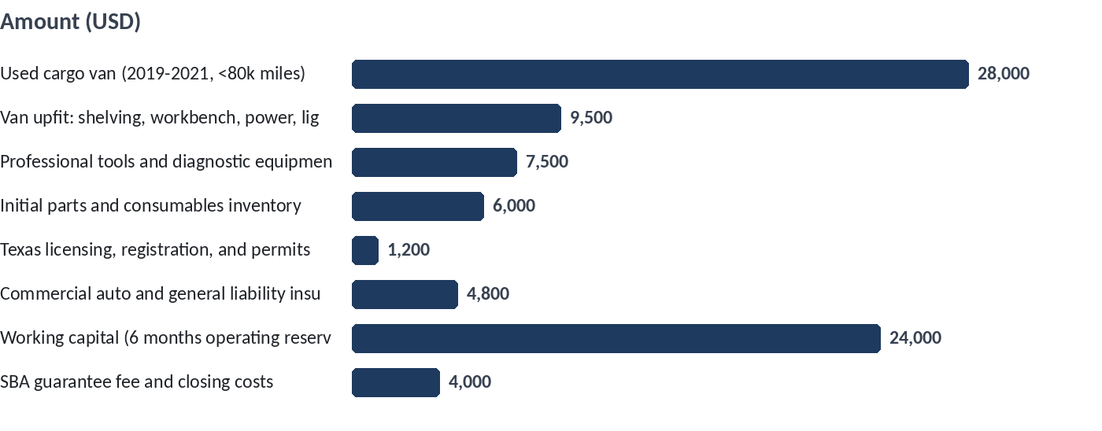
Figure 3. Amount (USD)
Repayment Term | Rate | Monthly Payment (USD) | Total Interest (USD) | Total Repaid (USD)
10 years (120 months) | 8.5% fixed | 1,054 | 41,480 | 126,480

Collateral and Personal Guarantee. The loan will be secured by the van and equipment (estimated value $45,000) plus a personal guarantee. SBA 7(a) loans typically require personal guarantees from owners with 20% or more ownership. Confirm collateral requirements and guarantee terms with the lender.

$85,000  Loan Amount  SBA 7(a) request | $1,054  Monthly Payment  10-year term, 8.5% fixed | Month 7  Break-Even Month  Projected positive net cash flow | $45,000  Collateral Value  Van and equipment estimate

